Use Case Document
Common Mapping and Transformation Service

Owner: caAdapter Development Team
National Cancer Institute
Center for Biomedical Informatics and Information Technology
2115 East Jefferson Street
Rockville, MD 20852

 |   Center for Bioinformatics


DOCUMENT REVISION HISTORY
Version Number | Date | Description
1.0 | 31-Aug-09 | - Initial Draft
2.0 | 18-Aug-10 | - Expand to common mapping and transformation

Background/Summary
This document contains the use cases for the caAdapter Common Mapping and Transformation Service model. This module provides the following capabilities:
- Model and represent XSD as meta of generic XML, ISO 21090 enabled XML, CDA, CCD, CSV, HL7 v2
- Implement XML data parser conform with XSD
- Implement adaptors of data parser to support CSV, HL7 v2 as source data
- Produce XML instances conformed to XSD specification.
- Implement functionalities data manipulation functions
- Provide API for application and service integration
Table of Content
Background/Summary 3
1 Introduction 6
1.1 Overview 6
1.2 Related Documents 7
2 Actors and Goals 7
2.1 Medical Systems Analyst 7
2.2 Medical Application Developer 7
2.3 External System 7
3 Use Cases 7
3.1 Use Case 1 – Open Data Structures in the Source Panel of the Mapping Tool 8
3.1.1 Use Case Model 8
3.1.2 Brief Description 8
3.1.3 Primary Actor 8
3.1.4 Preconditions 8
3.1.5 Basic Flow of Events 8
3.1.6 Alternative Flow 9
3.1.7 Post Conditions 9
3.1.8 Special Requirements 9
3.2 Use Case 2 – Open a Data Structure in the target Panel of the Mapping Tool 10
3.2.1 Use Case Model 10
3.2.2 Brief Description 10
3.2.3 Primary Actor 10
3.2.4 Preconditions 10
3.2.5 Basic Flow of Events 10
3.2.6 Alternate Flow 11
3.2.7 Post Conditions 11
3.2.8 Special Requirements 11
3.3 Use Case 3 – Map Source Data Elements from Source to Target Data Structures 12
3.3.1 Use Case Model 12
3.3.2 Brief Description 12
3.3.3 Primary Actor 12
3.3.4 Preconditions 12
3.3.5 Basic Flow of Events 12
3.3.6 Alternate Flow 13
3.3.7 Post Conditions 13
3.3.8 Special Requirements 14
3.4 Use Case 4 – Register Mapping Scenario 15
3.4.1 Use Case Model 15
3.4.2 Brief Description 15
3.4.3 Primary Actor 15
3.4.4 Secondary Actor 15
3.4.5 Preconditions 15
3.4.6 Basic Flow of Events 15
3.4.7 Alternate Flow 16
3.4.8 Post Conditions 16
3.4.9 Special Requirements 16
3.5 Use Case 5 – Transform Source Dataset(s) and Create a Target Dataset Using UI 17
3.5.1 Use Case Model 17
3.5.2 Brief Description 17
3.5.3 Primary Actor 17
3.5.4 Secondary Actor 17
3.5.5 Preconditions 17
3.5.6 Basic Flow of Events 17
3.5.7 Alternate Flow 18
3.5.8 Post Conditions 18
3.5.9 Special Requirements 18
3.6 Use Case 6 – Transform Source Dataset(s) and Create a Target Dataset Using Webservice APIs 19
3.6.1 Use Case Model 19
3.6.2 Brief Description 19
3.6.3 Primary Actor 19
3.6.4 Secondary Actor 19
3.6.5 Preconditions 19
3.6.6 Basic Flow of Events 20
3.6.7 Alternate Flow 20
3.6.8 Postconditions 20
3.6.9 Special Requirements 21
3.7 Overall Requirements 22
3.8 Requirements Prioritization 22
4 Sign Off 23
4.1 Approval 23

Introduction

Overview
The National Cancer Institute Center for Biomedical Informatics and Information Technology (NCI CBIIT) developed the caAdapter tool with the goal of creating standards-based infrastructure components to facilitate medical research data exchange. caAdapter is a open source tool kits including Module Mapping Service, HL7 Map and Transformation Service, Global Model Exchange Service, and Common Map and Transformation Service (CMTS). The module facilitates data mapping and transformation among different kinds of data sources including CSV, XML, HL7 v2 messages, HL7 v3 messages, and Study Data Tabulation Model (SDTM) data sets.

CTMS module is enabled with ISO 21090 standard which is jointly balloted between the International Organization for Standardization (ISO) and the Health Level Seven (HL7). ISO 21090 standards provides set of data type definitions for representing and exchanging basic concepts that are commonly encountered in healthcare environments in support of information exchange in the healthcare environment and specifies a collection of healthcare related data types suitable for us in a number of health related information environments. The semantics of these data types are declared with the terminology, notations and data types (referred to as the Language-Independent (LI) Data types) specified in ISO 11404 rev. 2005. The standard also provides UML definitions of the same data types using the terminology, notation and types defined in Unified Modeling Language (UML) version 2.0. XML definitions of the same data types are described with XML schema (XSD) derived from the UML representation of the specification using XML encoding rules and mapping between UML primitive types and XML types. The XSD provides a normative XML format for use when instance of these data are represented in XML. It is suitable for use when exchanging information between information processing entities. The XSD validation is required whether an XML instance is conformant with the ISO 21090 specification.
CTMS will be developed on the basis of XML schema (XSD) specification ^{[5]}. XSD file defines the structure, content and semantics of source data or target data. Mapping engine creates links between nodes of source XSD and target XSD. Transformation engine parses source data based source XSD, generates target data based target XSD using mapping data.
This Use Case Document captures the main use cases for caAdapter Common Mapping and Transformation Service module. This module will extend caAdapter’s data mapping and transformation capabilities to generate a target data in compliance with ISO 21090 XSD specification. It will employ the principals of the Service Oriented Architecture (SOA) for clinical data exchange.
The effort for developing this module will leverage existing caAdapter capabilities, and applicable open source packages.

Related Documents
- Common Mapping and Transformation Service Scope Document
- Common Mapping and Transformation Service Requirements
- Common Mapping and Transformation Service Design Document
- Common Mapping and Transformation Service User’s Guide

Actors and Goals
An actor is a person, organization, or external system that plays a role in one or more interaction with the Common Mapping and Transformation Service module. The following is a list of Actors that interact with this module:

Medical Systems Analyst
This actor will use the Common Mapping and Transformation Service module to map and transform from various datasets with a target datasets defined with metadata (XSD).

Medical Application Developer
This actor is responsible for developing map and transform from various datasets with a target datasets defined with metadata (XSD).

External System
This actor represents any External System that interacts with the Common Mapping and Transformation Service module using its APIs. The external system’s GUI is not represented by this actor.

Use Cases
The Common Mapping and Transformation Service module will be developed with multiple iterations. The first iteration will implement rules for XML representation of data types defined with XSD. It will only support map and transformation from XML source data to target XML data containing data types defined with XSD. Validation functionalities and additional formats of source data will be implemented in the future iterations (releases).

Use Case 1 – Open Data Structures in the Source Panel of the Mapping Tool

Use Case Model
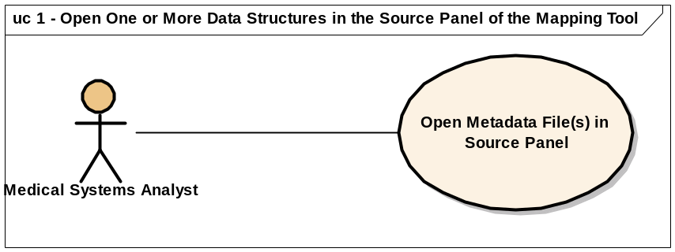

Brief Description
A Medical Systems Analyst is constructing an XML message to submit to another information system (target System). The target XML message contains one or more elements. The content of the XML message will be extracted from one, or more, local information system (Source Systems).
This use case covers reading source metadata file(s) for a data structure, and displaying that in the source panel of the mapping tool.
The first iteration supports source dataset with generic XML format, CSV, and HL7 v2 message.

Primary Actor
Medical Systems Analyst

Preconditions
- The Analyst is ready to begin the process of mapping one, or more, data structure using the Common Mapping and Transformation Service module UI
- Source metadata file(s) (XSD) exists

Basic Flow of Events
- The Analyst launches the Common Mapping and Transformation Service module UI
- The Analyst selects an option to open a source metadata file (XSD)
- The Analyst selects a metadata file from the file system
- The system automatically recognizes the type of the data structure represented in the metadata file identified by the Analyst
- The system validates the selected metadata file (Optional step).
- The system displays the data structure in a tree structure in a sub-window within the source panel of the mapping tool

Alternative Flow
N/A.

Post Conditions

Success Condition
The system displays a data structure in the source panel

Error Condition
The system cannot recognize the metadata file. The system will display an error describing the issue, and provides the Analyst with possible solution(s).

Special Requirements
N/A

Use Case 2 – Open a Data Structure in the target Panel of the Mapping Tool

Use Case Model
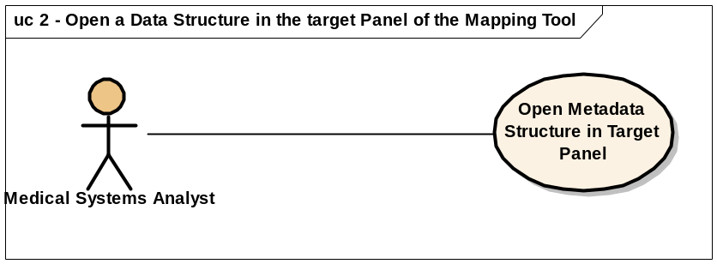

Brief Description
A Medical Systems Analyst is constructing an XML message to submit to another information system (target System). The target XML message contains one or more elements of data types defined with XSD. The content of the XML message will be extracted from one, or more, local information system (Source Systems).
This use case covers reading a target metadata file and displaying that in the target panel of the mapping tool.

Primary Actor
Medical Systems Analyst

Preconditions
- The Analyst is ready to begin the process of mapping one or more, data structure using the Common Mapping and Transformation Service module UI
- Target metadata file exists

Basic Flow of Events
- The Analyst launches the Common Mapping and Transformation Service module UI
- The Analyst open a target metadata file
- The Analyst selects a metadata file from the file system
- The system automatically recognizes the type of data structure represented in the metadata file identified by the Analyst.
- The system validates the selected metadata file (Optional step)
- The system displays the data structure in a tree structure in a target panel of the mapping tool.
- The Analyst can only open one metadata file in the target panel

Alternate Flow
N/A

Post Conditions

Success Condition
The system displays the data structure in the target panel

Error Condition
The system is unable to recognize the metadata file. The system will display an error describing the issue, and providing the Analyst with possible solution(s)

Special Requirements
N/A

Use Case 3 – Map Source Data Elements from Source to Target Data Structures

Use Case Model
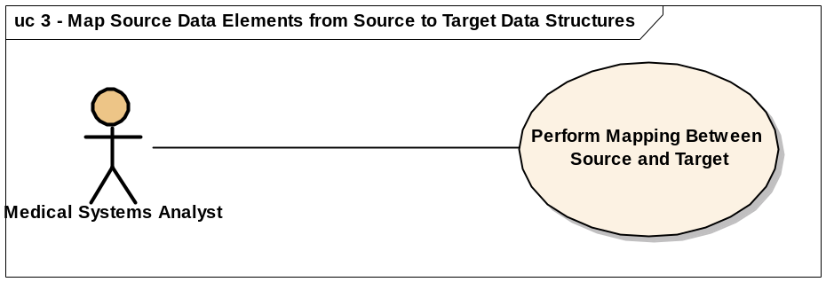

Brief Description
A Medical Systems Analyst is constructing an XML message to submit to another information system (target System). The target XML message contains one or more elements of data types defined with XSD. The content of the XML message will be extracted from one, or more, local information system (Source Systems).
This use case covers the mapping activities from the source to the target data elements

Primary Actor
Medical Systems Analyst

Preconditions
- The Analyst is ready to start the process of mapping one or more data structure using the Common Mapping and Transformation Service module UI
- The Analyst has opened one source data structure in the source panel of the mapping tool
- The Analyst has opened a target data structure in the target panel of the mapping tool

Basic Flow of Events
            - The Analyst selects a source data element by clicking on it and dragging it over a target data element
            - The System validates the mapping. The validation rules must be congruent with the data mapping validation rules currently implemented.
The system must provide a scalable implementation of the validation rules to facilitate incorporating future validation rules as they are identified
            - The Analyst uses data manipulation function(s) between source and target data elements. The functions will be used during data transformation.
The system must provide a scalable implementation of the data manipulation functions, and an easy way to incorporate new functions in the future
            - The Analyst can delete:
              - A single mapping line
              - All visible mapping lines
For any mapping line delete action, the Analyst must provide confirmation before the system executes the delete operation
            - The Analyst selects an option to save the mappings. The system provides the Analyst the option to choose a file name and location for saving mapping information
            - The Analyst should be able to recall the saved file and edit the mappings

Alternate Flow
  - The Analyst opens a mapping file created and saved earlier
  - The next steps in this flow are identical to steps 1 through 6 above. In addition, the Analyst must be able to edit a previously defined function

Post Conditions
N/A

Success Conditions
- The Analyst is able to perform mappings between source and target data elements
- Mappings are validated correctly according to identified validation rules
- Lines representing the mappings are drawn correctly and clearly
- The delete operation deletes specified mapping lines, and associated functions if they exist
- The save operation successfully saves the mapping file in the specified location
- A saved mapping file could be updated by the Analyst at a later time

Error Conditions
The system generates an exception message explaining the problem, and advising the Analyst of possible solutions, when one or more of the following occurs:
- The system is unable to save the mapping file
- The system is unable to open a previously saved mapping file for any of the following reasons:
- Corrupt mapping file
- Missing or corrupt source metadata file(s)
- Missing or corrupted target metadata file
- The source metadata file was modified since the last time the mapping file was saved
- The target metadata file was modified since the last time the mapping file was saved

Special Requirements
The map file must be a text file.

Use Case 4 – Register Mapping Scenario

Use Case Model
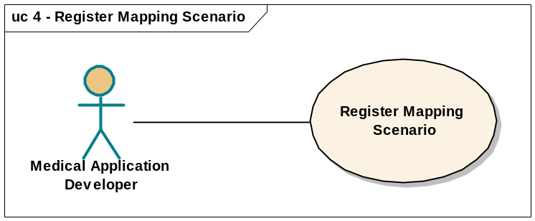

Brief Description
This use case covers the registration of the mapping scenario with the caAdapter Webservice Portal. The registered scenario will be used later to perform transformation, data validation, and persistence tasks.

Primary Actor
Medical Application Developer

Secondary Actor
N/A

Preconditions
- The developer has the completed mapping file, along with the source and target schema files

Basic Flow of Events
- The developer signs on to the caAdapter Webservice Portal. If the developer does not have an account on the Portal, She or he must be able to use the Portal to obtain one immediately by registering
- The developer initiates the registration process and provides the following information:
  - A unique scenario name (unique within this user’s stored scenarios)
  - The map file
  - Source metadata file
  - Target metadata file
For items (b) and (c) above, the developer must be able to locate the file on his/her local system to be uploaded to the Portal
- The Portal stores the information provided by the developer after verifying that:
  - The scenario name is unique
  - The map, source metadata, and target metadata files exist
- The system presents the user with a confirmation of the save operation once the verifications above have been successfully executed.

Alternate Flow
- The developer browses previously uploaded scenarios and selects one
- The developer may edit, delete, or download any component of the scenario
- If the developer had uploaded several scenarios, she or he can use a search function to locate a specific scenario

Post Conditions
N/A

Success Conditions
- The information provided by the user have been verified and saved correctly by the Portal

Error Conditions
One or more of the following conditions will cause the system to generate an error message back to the developer:
- Scenario name is not unique – within the list of scenarios the name has saved under the user’s account
- The map, source metadata or target metadata files do not exist

Special Requirements
N/A

Use Case 5 – Transform Source Dataset(s) and Create a Target Dataset Using UI

Use Case Model
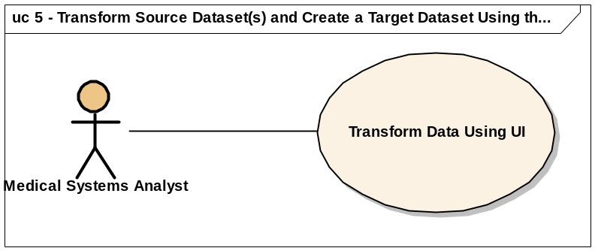

Brief Description
A Medical Systems Analyst is constructing an XML message to submit to another information system (target System). The target XML message contains one or more elements of data types defined with XSD. The content of the XML message will be extracted from one, or more, local information system (Source Systems).
This use case covers the activities involved in transforming source data to create a target dataset using the target metadata and mappings defined by the Analyst using the module UI.

Primary Actor
Medical Systems Analyst

Secondary Actor
N/A

Preconditions
- Mapping between the source and target data has been completed
- A valid mapping file was created

Basic Flow of Events
- The Analyst opens a map file using the UI, then selects the data transformation option
- The system asks the user to specify the source dataset(s), and the name and location of the target dataset file
- The system uses the source datasets files and mapping file to create the target dataset file

Alternate Flow
- Application invokes the transformation process with Java API

Post Conditions
N/A

Success Conditions
- The system creates the target dataset compliant with the target metadata, and correctly employing the mapping and transformation rules defined by the Analyst

Error Conditions
The system generates an exception message explaining the problem, and advising the Analyst of possible solutions, when one or more of the following occurs:
- The system is unable to process the provided file(s)
- The system is unable to save the target dataset
- Joining one or more source datasets based on the relationships defined in the map file resulted in creating an unusually large result set, i.e. a Cartesian product. The system must warn the user in this case and provide the option to terminate the transformation process (low priority)

Special Requirements
N/A

Use Case 6 – Transform Source Dataset(s) and Create a Target Dataset Using Webservice APIs

Use Case Model
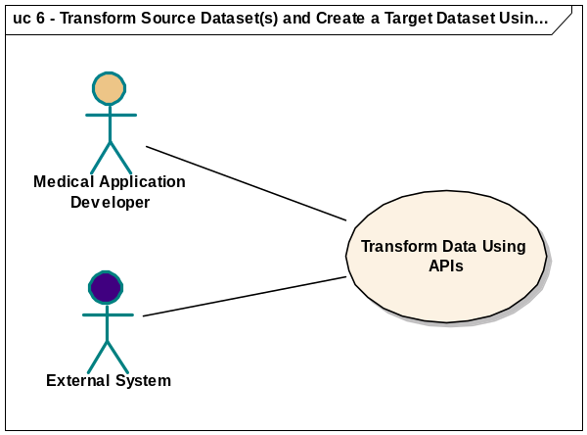

Brief Description
A Medical Systems Analyst is constructing an XML message to submit to another information system (target System). The target XML message contains one or more elements of data types defined with XSD. The content of the XML message will be extracted from one, or more, local information system (Source Systems).
This use case covers the activities involved in transforming source data to create a target dataset using the target metadata and mappings defined by the Analyst using the caAdapter Common Mapping and Transformation Service module webservice APIs

Primary Actor
Remote users – Medical Analyst

Secondary Actor
External System

Preconditions
- The mapping scenario has been registered at the Webservice Portal

Basic Flow of Events
- The user issues invoke a transformation process to the caAdapter Webservice and provides the following:
  - User authentication information needed to authenticate the developer to the Portal
  - scenario name
  - Source dataset(s)
- The system uses stored scenario information to transform the source datasets provided by the user
- Once completed, the system will return the transformation file, and a log file to the developer containing the following information:
- Total number of records in each source dataset
- Total number of records in the transformation file
- Errors occurred during the transformation with specific explanation, and possible solutions

Alternate Flow
N/A

Postconditions

Success Conditions
- The system creates the target dataset compliant with the target metadata, and correctly employing the mapping and transformation rules defined by the Analyst

Error Conditions
The system generates an exception message explaining the problem, and advising the Analyst/External System of possible solutions, when one or more of the following occurs:
- The system is unable to open the provided file(s)
- The system is unable to save the target dataset (transformation file)
- Joining one or more source datasets based on the relationships defined in the map file resulted in creating an unusually large result set, i.e. a Cartesian product. The system must warn the user in this case and provide the option to terminate the transformation process (low priority)

Special Requirements
N/A

Overall Requirements
TBD

Requirements Prioritization
TBD
Priority | Use Case Name | Supp Requirement Ref #

Sign Off

Approval

Workspace General Contractor Rep Print Name Date
Architecture Workspace Rep Print Name Date
VCDE Workspace Rep Print Name Date
Workspace Working Group Rep Print Name Date
NCICB Rep Print Name Date

